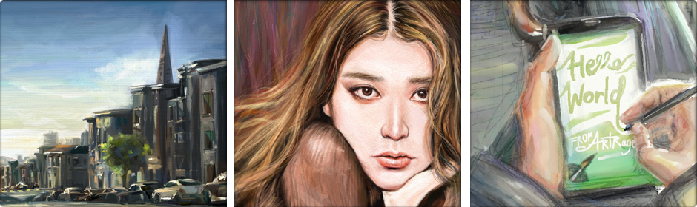

AMBIENT DESIGN LAUNCHES ARTRAGE PAINTING
SOFTWARE FOR ANDROID

ArtRage for Android Optimized for Samsung Galaxy Note 4,
Selected for GALAXY Gift as Free Download

Highlights the Samsung Galaxy Note 4’s S Pen for
Artistic & Creative Expression on Mobile Devices

Auckland, New Zealand, October __, 2014 -- Ambient Design (www.artrage.com), the award-winning creator of realistic art software, announced today that it is launching ArtRage for Android, optimized for the Samsung Galaxy Note 4. Samsung has selected ArtRage for availability in a number of global markets for GALAXY Gift. This will provide Note 4 and Note Edge users the exclusive ability to download the software for free.

ArtRage for Android will launch at the same time on the Samsung GALAXY Apps for purchase by users of selected Samsung Galaxy mobile products.

ArtRage Creates Realistic Artwork On-the-Go without Appearing Computer Generated

ArtRage provides detailed paint blending and texture, using a simulation of natural artistic tools that work seamlessly with the advanced features of the Samsung Galaxy Note 4’s S Pen to enable users to create realistic artwork on-the-go. Artists can use ArtRage on the Samsung Galaxy mobile platform to share their artwork via popular artist communities and social media sites, like PEN.UP, deviantArt, Facebook, Twitter, and Flickr, as well as send art by email or save to Dropbox.

“With ArtRage and the S Pen, mobile art can be created without waiting for paint to dry and without carrying a lot of artist’s tools, paints, canvas and paper,” said Matt Fox-Wilson, creative director and co-founder of Ambient Design Ltd.
“ArtRage provides the experience of actually ‘painting’ digitally on a computer canvas with oil paints that smear and blend, and watercolors that flow together to create soft, wet gradations, just as they would in a traditional art studio.”

ArtRage Features:

Real World Painting Tools Including:

- High quality rendered strokes show the amount of paint on the canvas, letting you play with texture as well as color.
- Oil Brush with paint thickness and smearing.
- Watercolor with fluid dynamics to simulate stroke blending and spreading.
- Airbrush with soft color spray.
- Palette Knife for spreading and blending pigment.
- Paint Roller & Tube for laying down thick coats of paint.
- Inking Pen with auto-smoothing and pressure simulation.
- Pencil & Marker Pen, Chalk & Crayon and Eraser for drawing and sketching.
- Flood Fill.
- Settings for fine control of each tool and custom tool presets for storing favorites.

Layers:

- Unlimited layers with available memory.
- Improved color blending.
- Easy to save incremental copies.
- Blend Modes, including Photoshop standards.
- Easy access to visibility/opacity.

Utilities:

- Unlimited Undo/Redo.
- Reference & Tracing Images to help you as you paint.
- Unlimited color samples.

For a limited time ArtRage for Android will be available exclusively from Samsung GALAXY Apps, free for Galaxy Note 4 and Note Edge users through Samsung GALAXY Gifts. For other Samsung Galaxy mobile device users, it will also be available at US$4.99. Check GALAXY Apps in your region for details. ArtRage support for additional Android devices is planned for early 2015.

ArtRage is also available for Mac and Windows and is compatible with Wacom styluses. ArtRage for Mac and Windows is priced at $49.90 from: http://www.artrage.com/artrage-store.html. ArtRage for iPad and ArtRage for iPhone are priced at $4.99 and $1.99 respectively from the Apple iTunes Store.For more information, see www.artrage.com, Facebook: www.facebook.com/artrage, or Twitter: @ArtRage https://twitter.com/ArtRage
About Ambient Design Ltd.
Ambient Design Ltd. is a New Zealand-based global software development and publishing firm, specializing in creative applications and user interfaces for artists of all ages and all levels of competency, including professionals, hobbyists and students. The principals have over 40 years’ experience in combining complex image processing algorithms with an easily accessible user experience. Ambient Design Ltd. was founded in 2000 by Andy Bearsley and Matt Fox-Wilson, formerly of MetaCreations, the developer of Painter, Bryce and Kai’s Power Tools. Ambient Design’s products are available in up to 14 languages and have been downloaded over 30 million times across various platforms. For more information, see www.artrage.com.

ArtRage 4 Logo:
http://www.artrage.com/press-section/ar4logo_120/ (small)
http://www.artrage.com/press-section/arlogo_480/ (large)

Videos: http://www.youtube.com/user/artragetv
Press Contact & More Information

press@artrage.com
http://www.artrage.com/press-section/

ArtRage Social Media and Communities:
- ArtRage Forums (Ambient Design): share techniques and artwork with other ArtRage users.
- ArtRage on DeviantART: official DeviantART group for ArtRage artwork, tutorials, contests, galleries and art resources featuring a regular monthly contest offering the chance to win a copy of ArtRage 4.5 as well as an opportunity for fun and practice for their artists.
- ArtRage Facebook Community: Facebook group for ArtRage users.
- ArtRage on Twitter.
- ArtRage on Tumblr: Tumblr ArtRage artwork and painting tips and tricks.
- ArtRage Flickr Group: (not moderated by Ambient Design staff).

ArtRage and the BrushMan logo are trademarks of Ambient Design Ltd. All other trademarks are property of their respective owners.

